ENTITY/DEFINITION MATRIX

Team Number: ____3______

Team Members: Kristina, Charles-Etienne, Austin

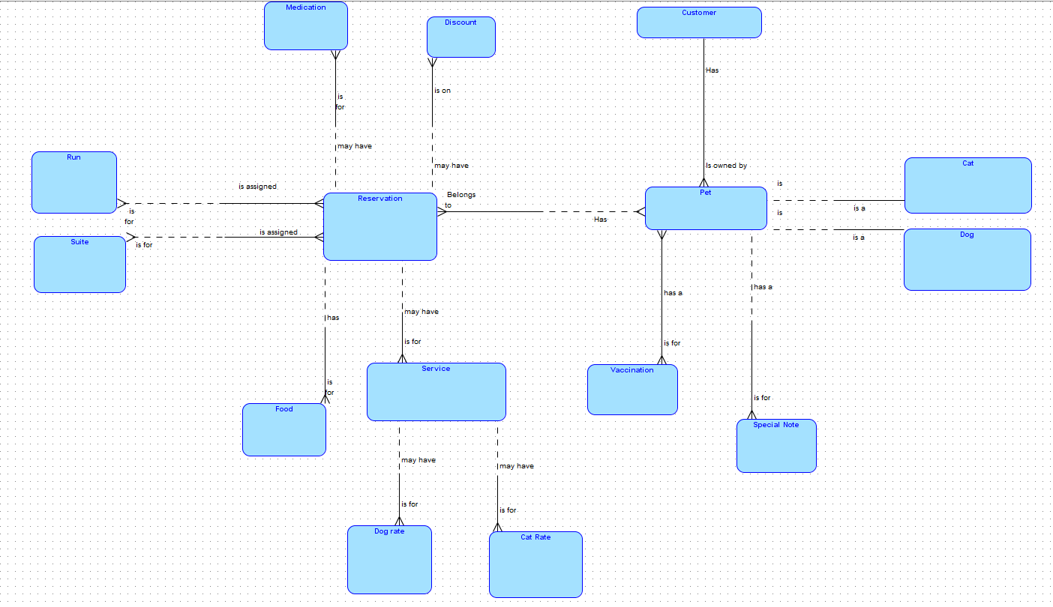

Note: capture all high level user stories, business rules related to the Entity.

| **Entity Name** | **ShortName** | **Definition, Description, User Story, Rules** |
| --- | --- | --- |
| Dog Information | dog | In this, we keep the dog’s information like his name, breed, age, size, vaccination,sex |
| cat information | cat | In this, we keep the cat’s information like his name, breed, age,sex |
| customer information | Customer | In this we keep the customer’s information like the name, address, phone number, pet name |
| run |  | In this, we keep the run information, number an its attributes (for barkers, for non-barkers) |
| suite |  | In this, we keep the suite information like its luxury level |
| Service |  | In this, we keep the different types of services (grooming, walks, medication) |
| Food |  | In this we keep the different kind of foods |
| Dog Rate |  | In this we keep the different prices that are available at the kennel for dogs |
| Pet information | Pet | In this we keep the pet information with no regards to if they are a cat for a dog |
| Reservation |  | This is the heart of our database. It stores the information of the customers and pet information for a given date |
| Cat Rate |  | In this we keep the different prices that are available at the kennel for cats |
| vaccination |  | Specifies the information about the vaccination of the pet |
| medication |  | Specifies the information about the medications for the pets |
| Discount |  | Specifies the discount of the animals |
| Special note |  | Specifies the special notes for a pet |
|  |  |  |
|  |  |  |
|  |  |  |
|  |  |  |
|  |  |  |
|  |  |  |
|  |  |  |
|  |  |  |
|  |  |  |
|  |  |  |

Relationship Definitions

| **First Entity** | **Second Entity** | **Relationship Name** | **Cardinality** | | **Relationship Definition** |
| --- | --- | --- | --- | --- | --- |
| **Min[1]** | **Max** |
| Customer | *Pet* | *Customer to pet* | *required* | *multiple* | *Customer has pet and pet is owned by customer* |
| Pet | Customer | Pet to Customer | required | single | *Customer has pet and pet is owned by customer* |
| Pet | Reservation | Pet to reservation | optional | multiple | Pet can have reservation and reservation belongs to Pet |
| Reservation | Pet | Reservation to pet | required | mutliple | Pet can have reservation and reservation belongs to Pet |
| Pet | Dog | Pet to Dog | Optional | single | Pet Can be a dog and dog is a pet |
| Dog | Pet | Dog to pet | required | single | Pet Can be a dog and dog is a pet |
| Pet | Cat | Pet to Cat | Optional | single | Pet Can be a cat and cat is a pet |
| Cat | Pet | Cat to Pet | required | single | Pet Can be a dog and dog is a pet |
| Service | Cat Rate | Service to cat rate | optional | multiple | The service can have a or many cat rate |
| Cat Rate | Service | Cat rate to Service | required | single | Cat rate is for service |
| Pet | Vaccination | Pet to vaccination | required | multiple | Pet has to get many vaccination |
| Vaccination | Pet | Vaccination to pet | required | multiple | Multiple Vaccinations were given to a pet |
| Pet | Special note | Pet to special note | Optional | multiple | pet Can have a special note |
| Special note | Pet | Special note to pet | required | single | Special note has to be written on a pet |
| Service | Dog Rate | Service to dog rate | optional | multiple | The service can have a or many dog rates |
| Dog Rate | Service | dog rate to Service | required | single | dog rate is for service |
| reservation | food | Reservation to food | Optional | multiple | A reservation can be made with one or many foods |
| Food | reservation | Food to reservation | required | Single | Food can be a part of a reservation |
| reservation | Service | Reservation to service | optional | Multiple | A reservation can be booked with one or many services |
| Service | Reservation | Service to reservation | required | single | A service has to be in a reservation |
| Reservation | run | Reservation to run | required | Multiple | A reservation has to be booked for one or multiple runs |
| run | reservation | Run to reservation | optional | multiple | A run can be in a reservation |
| Reservation | Suite | Reservation to suite | required | Multiple | A reservation has to be booked for one or multiple suitess |
| Suite | reservation | suite to reservation | optional | multiple | A suite can be in a reservation |
| Reservation | Discount | Reservation to discount | Optional | Multiple | A reservation can have multiple discounts |
| discount | reservation | Discount to reservation | Required | single | A discount has to be for a reservation |
| reservation | Medication | Reservation to medication | Optional | multiple | Reservations can have one or many medications |
| medication | Reservation | Medication to reservation | required | single | Medication has to be put in a reservation |
|  |  |  |  |  |  |
|  |  |  |  |  |  |
|  |  |  |  |  |  |
|  |  |  |  |  |  |

1. Optionality